Kevin Alexander

March 17,2024

CS-230-R4748 Operating Platforms

Instructor:Bryant Moscon

Project One UML Diagram

Game Application

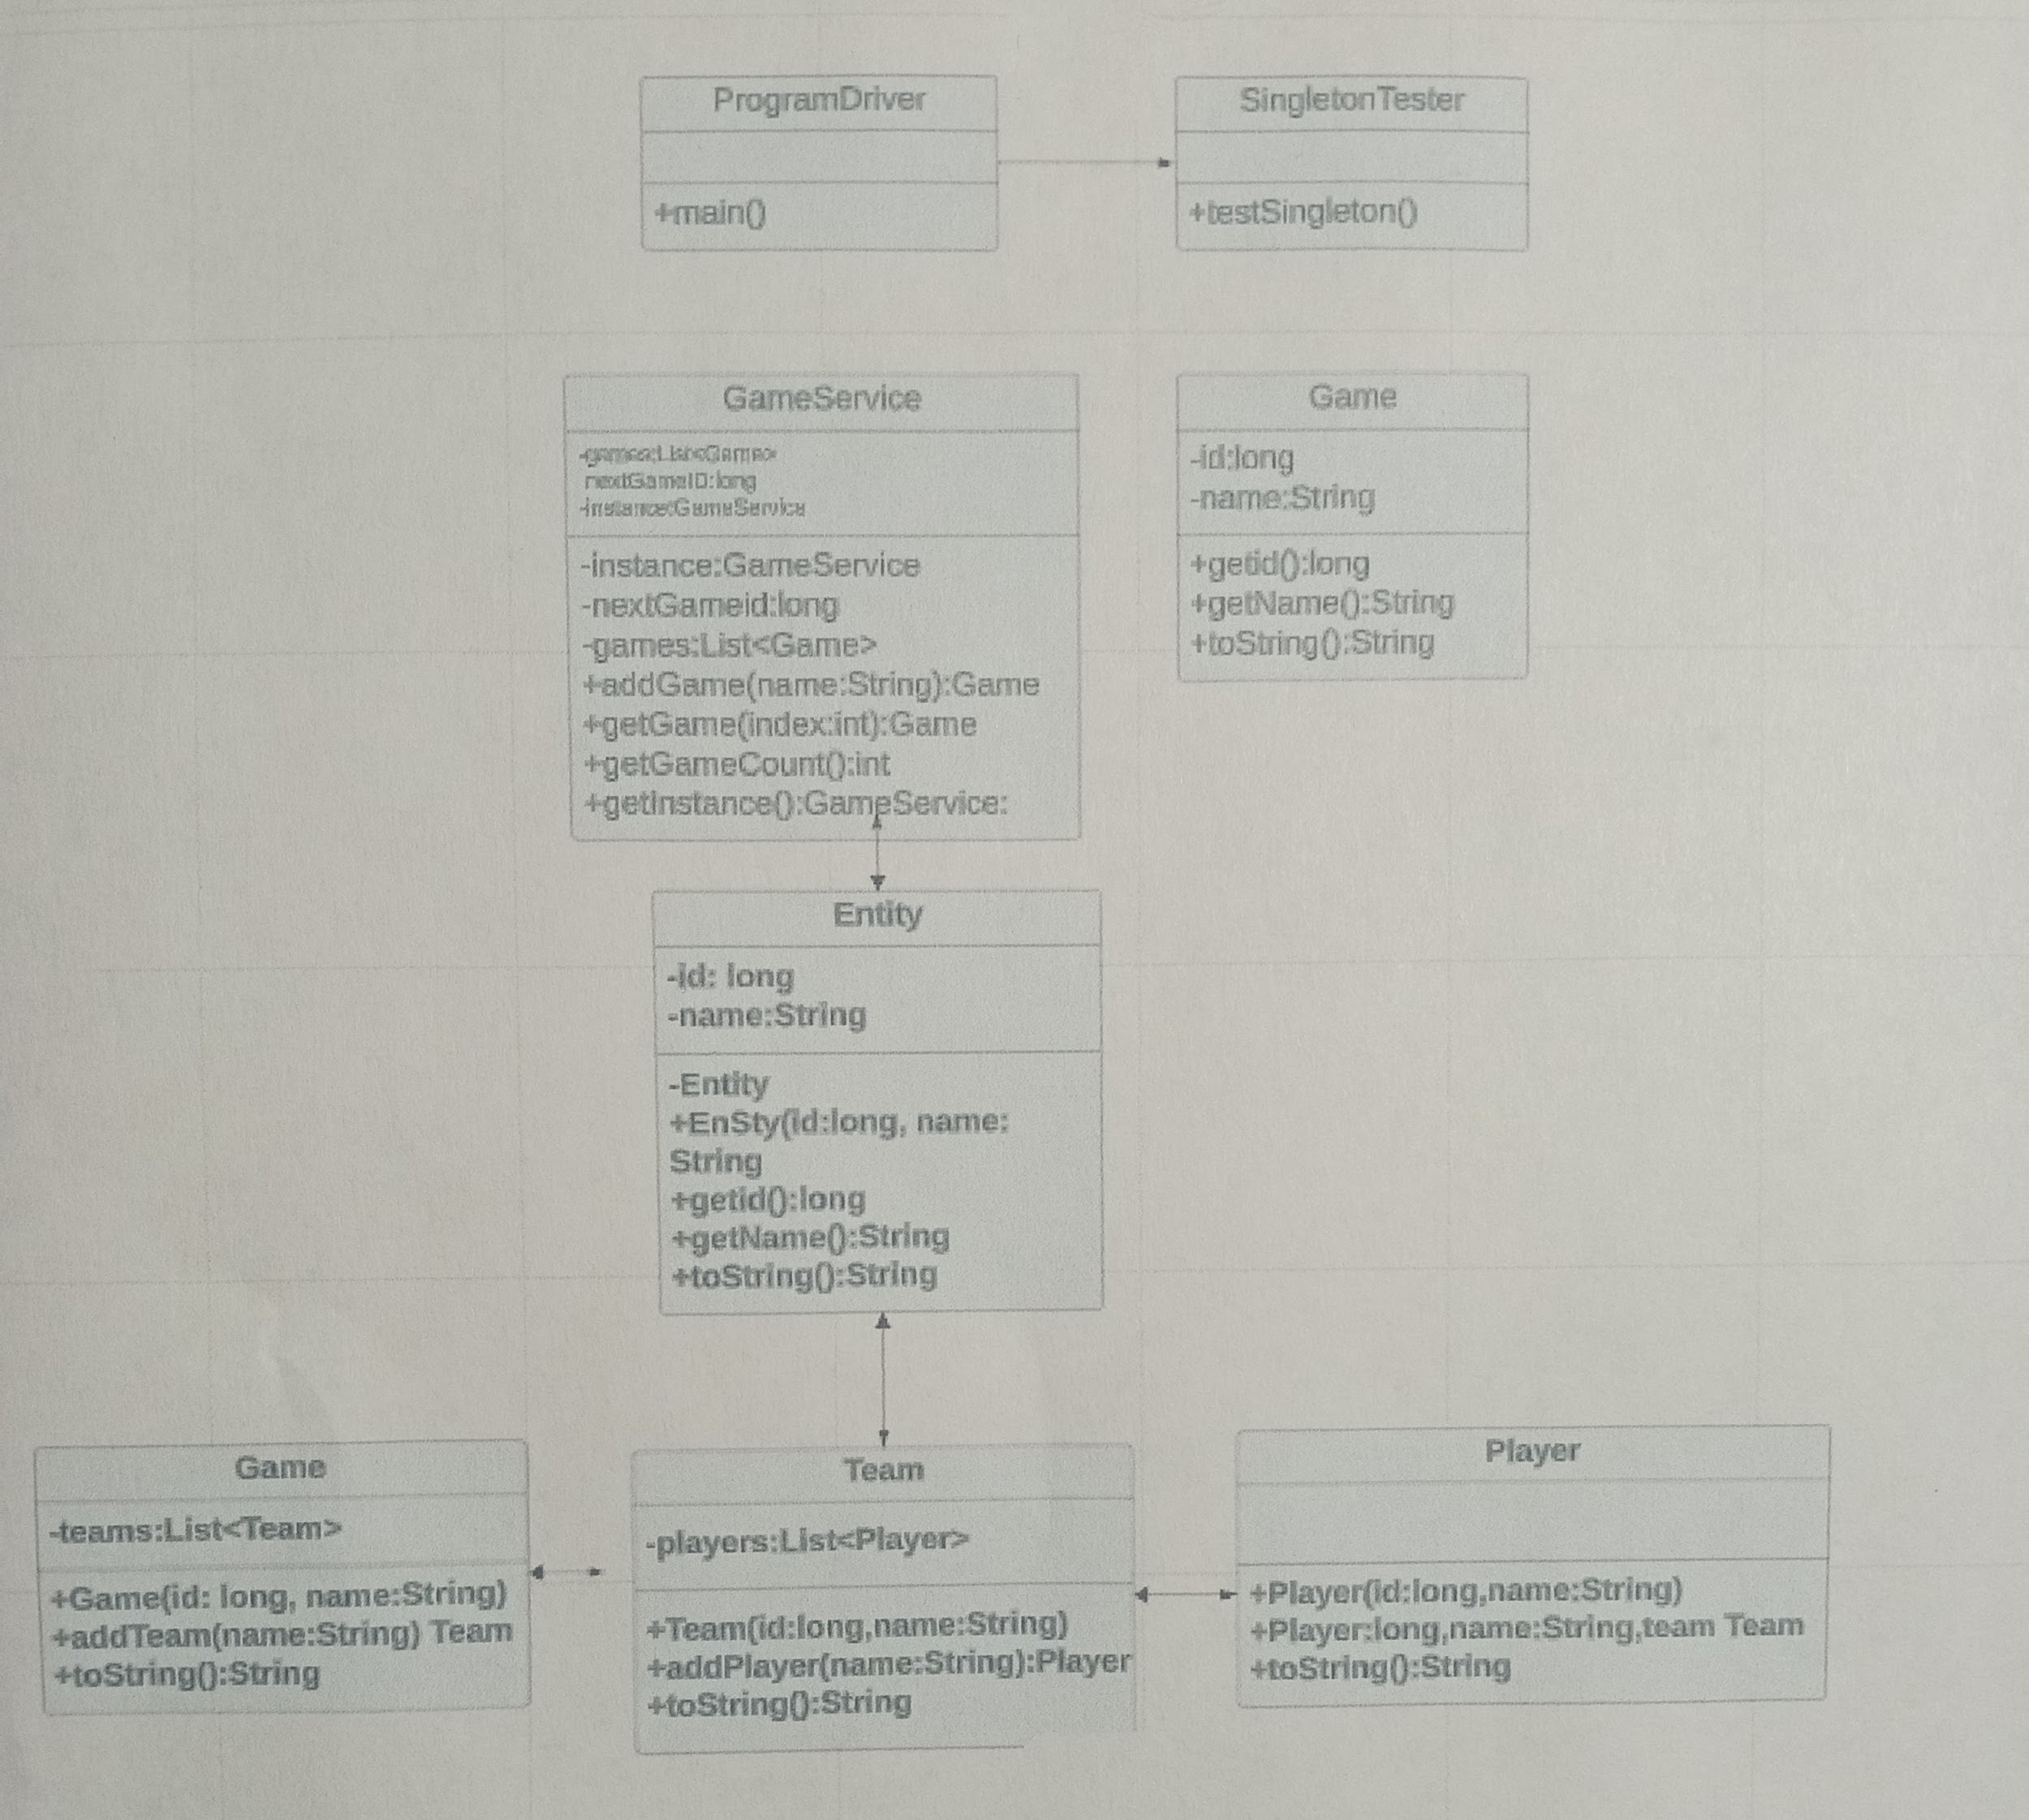

UML (Unified Modeling Language) diagrams are used to visually represent the design of a system. They do not inherently create unique identifiers themselves. Unique identifiers in a system are typically defined and managed within the system’s data model or database schema. In UML diagrams,unique identifiers can be represented by attributes marked as unique or primary keys in class diagrams, entity-relationship diagrams, or database diagrams. These unique identifiers help distinguish individual instances of classes or entities within the system.